
INDIAN SCHOOL AL WADI AL KABIR
MID TERM EXAMINATION 2025-26

ARTIFICIAL INTELLIGENCE (417)

Class: X Max Marks: 50
Date: 25-09-2025 Time: 2 Hour

SECTION A: OBJECTIVE TYPE QUESTIONS

1 | Answer any 4 out of 5 questions from Employability skills
i | Which of the following is NOT an element of communication within the communication process cycle?  (a) Channel  (b) Receiver  (c) Sender  (d) Time | 1
ii | Which of the following is an example of oral communication?  (a) Newspapers  (b) Letters  (c) Phone call  (d) e-mail | 1
iii | Which of these are examples of positive feedback?  (a) Excellent, your work has improved.  (b) I noticed your dedication towards the project.  (c) You are always doing it the wrong way.  (d) All of the above | 1
iv | Ravi works hard to get the best student award at the end of year. What type of motivation is this?  (a) Internal  (b) External  (c) Both internal and external  (d) Not any specific type of motivation | 1
v | Which of these sentences is in active voice?  (a) A movie is being watched by them.  (b) The car was repaired by Raju.  (c) He is reading a book.  (d) The thief was being chased by a policeman. | 1
2 | Answer any 5 out of 6 questions from subject specific skills
i | Read the examples given below-  - Using Chat GPT to write an email  - Face unlock technology of mobile phones using camera  - Turning off lights with IoT device  - Hand sanitizer dispenser having sensor  Choose the options that are not AI  (a) i and ii  (b) iii and i  (c) iii and iv  (d) i, iii and iv | 1
ii | What is the main goal of Computer Vision projects?  - Translating audio data into visual descriptions  - Converting digital data into analogue signals  - Teaching machines to understand textual information  - Converting digital visual data into computer-readable language | 1
iii | The Indian Government banned a few apps stating – “servers in the hostile nation are receiving and using the acquired data improperly”. Which terminology suits best for this action?  (a) AI Ethics  (b) Data Privacy  (c) AI Bias  (d) AI Access | 1
iv | Assertion: Ethics provide guidance in distinguishing right from wrong.  Reasoning: Ethics consist of a set of values and morals that aid individuals in making moral judgments and decisions.  - Both Assertion and Reasoning are true, and Reasoning is the correct explanation of the Assertion.  - Assertion is true, but Reasoning is false.  - Both Assertion and Reasoning are true, but Reasoning is not the correct explanation of the Assertion.  - Assertion is false, but Reasoning is true. | 1
v | Statment1: The output given by the AI model is known as reality.  Statement2: The real scenario is known as Prediction.  (a) Both Statement1 and Statement2 are correct  (b) Both Statement1 and Statement2 are incorrect  (c) Statement1 is correct but Statement2 is incorrect  (d) Statement2 is correct but Statement1 is incorrect | 1
vi | F1 Score is the measure of the balance between  (a) Accuracy and Precision  (b) Precision and Recall  (c) Recall and Accuracy  (d) Recall and Reality | 1
3 | Answer any 5 out of 6 questions from subject specific skills
i | What is the primary domain of application for Bioethics?  A) Agriculture  B) Healthcare and life sciences  C) Information technology  D) Environmental conservation | 1
ii | What is the purpose of defining the problem statement during the Problem Scoping stage in an AI project cycle?  A) To collect data  B) To understand the aim and objective of the project  C) To train the model  D) To process data | 1
iii | Which learning approach uses labelled data for training?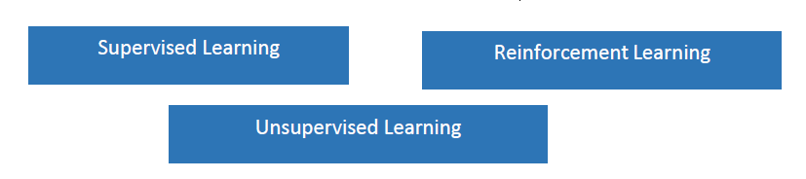  c..  b..  a.. | 1
iv | Assertion: Unsupervised Learning is a type of learning without any guidance.  Reasoning: Unsupervised learning models work on unlabelled datasets, where the data fed into the machine is random and the person training the model may not have any prior information about it.  - Both A and R are true and R is the correct explanation for A  - Both A and R are true and R is not the correct explanation for A  - A is True but R is False  - A is false but R is True
v | In a medical test for a rare disease, out of 1000 people tested, 50 actually have the disease while 950 do not. The test correctly identifies 40 out of the 50 people with the disease as positive, but it also wrongly identifies 30 of the healthy individuals as positive. What is the accuracy of the test?  - 97%  - 90%  - 85%  - 70%
vi | Identify the model: Predicting whether a customer is eligible for a bank loan or not?  a. Classification  b. Regression  c. Both a. and b.  d. None of the above
4 | Answer any 5 out of 6 questions from subject specific skills
i | Which of these is an example of AI in e-commerce applications?  a) Login  b) checkout  c) Recommendations  d) Logout
ii | Aditi, a student of class XII developed a chatbot that clarifies the doubts of Economics students. She trained the software with lots of data sets catering to all difficulty levels. If any student would type or ask questions related to Economics, the software would give an instant reply. Identify the domain of AI in the given scenario.  a. Computer Vision  b. Data Science  c. Natural Language Processing  d. None of these
iii | Statement1: There are four layers in a neural network.  Statement2:The first layer of the neural network is known as the output layer.  a. Both Statement1 and Statement2 are correct  b. Both Statement1 and Statement2 are incorrect  c. Statement1 is correct but Statement2 is incorrect  d. Statement2 is correct but Statement1 is incorrect
iv | _________ ___________is defined as the percentage of correct predictions out of all the observations.  a. Overfitting  b. Accuracy  c. Confusion Matrix  d. Data acquisition
v | How are Ethical Frameworks for AI categorized?  a) Into legal and illegal frameworks  b) Into sector-based and value-based frameworks  c) Into historical and contemporary frameworks  d) Into theoretical and practical frameworks
vi | __________________________ refer to the type of data you want to collect.  a. Data features  b. Exploring Data  c. Data Acquisition  d. All of the above
5 | Answer any 5 out of 6 questions from subject specific skills
i | Clustering is learning and its goal is to?  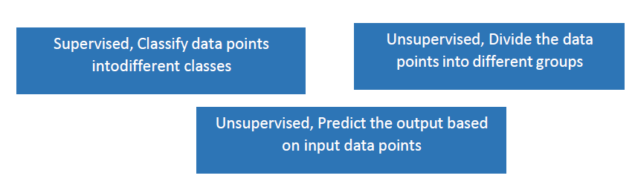  c.  b.  a..
ii | Assertion (A): Neural networks are the backbone of deep learning algorithms  Reasoning (R): Neural networks use vast amounts of data  a. Both A and R are correct and R is the correct explanation of A  b. Both A and R are correct but R is NOT the correct explanation of A  c. A is correct but R is not correct  d. A is not correct but R is correct.
iii | ___________ is the process of understanding the reliability of any AI model, based on outputs by feeding test dataset into the model and comparing with actual answers.  a. Evaluation  b. Problem Scoping  c. Data acquisition  d. Data Exploration
iv | The result of comparison between the prediction and reality can be recorded in what we call the __________.  a. Overfitting  b. Problem Scoping  c. Confusion Matrix  d. Data acquisition
v | The _______________ is the fifth stage of the AI project cycle.  a. Problem Scoping  b. Data Evaluation  c. Data Exploration  d. Data Modelling
vi | Whenever we want an AI project to be able to predict an output, we need to _______________ it first using data.  a. Analyze  b. Train  c. Explore  d. All of the above

SECTION B: SUBJECTIVE TYPE QUESTIONS

Answer any 3 out of the given 5 questions on employability skills in 20 – 30 words. (2 x 3 = 6 marks)
Q. 6 | Explain any 2 different types of verbal communication.  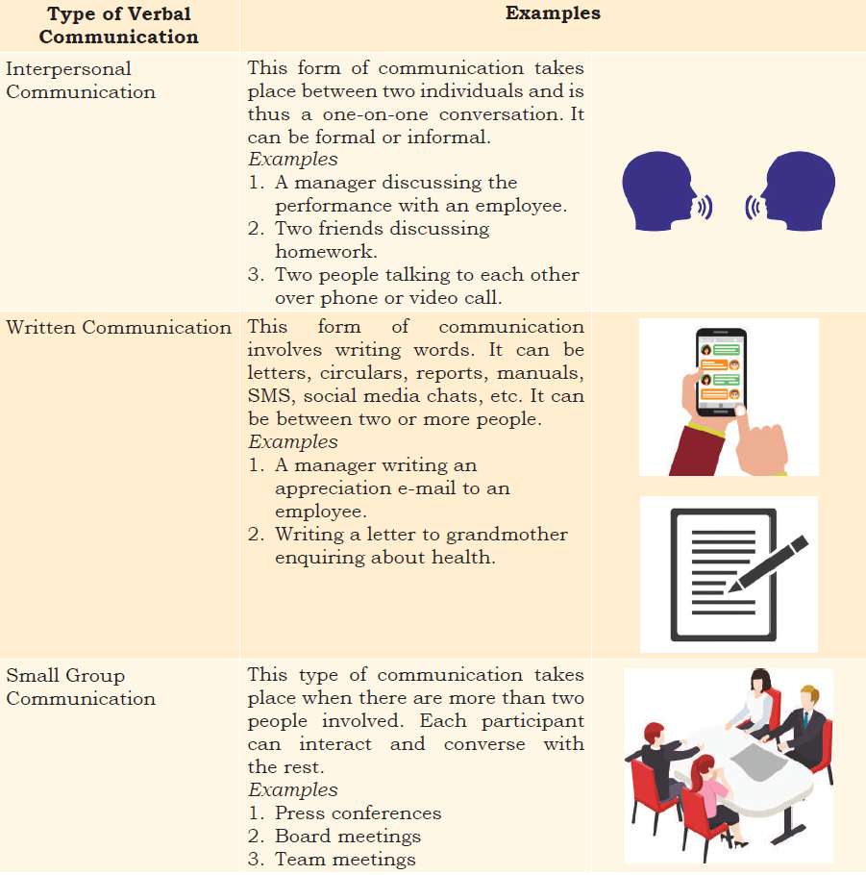 | 2
Q. 7 | Describe stress and stress management  What is Stress?  Stress can be defined as our emotional, mental, physical and social reaction to any  perceived demands or threats. These demands or threats are called stressors.  stress management  Managing stress is about making a plan to be able to cope effectively with daily pressures. The ultimate goal is to strike a balance between life, work, relationships, relaxation and fun. | 2
Q. 8 | What do you mean by feedback?  Feedback — The receiver conveys their understanding of the message to the sender in the  form of feedback to complete the communication cycle. | 2
Q. 9 | What is Goal Setting?  Goal setting: It is all about finding and listing your goals and then planning on how to achieve them. Goals allow you to separate out what’s important. It helps you to focus on the end result instead of less important work. This will make you successful in your career and personal life. | 2
Q. 10 | Write down the common communication barriers you may come across when you move to a new city or country.  Physical Barriers:  Physical barrier is the environmental and natural condition that act as a barrier in communication in sending message from sender to receiver.  Linguistic Barriers  The inability to communicate using a language is known as language barrier to communication.  Interpersonal Barriers  Barriers to interpersonal communication occur when the sender’s message is received differently from how it was intended.  Organisational Barriers  Organisations are designed on the basis of formal hierarchical structures that follow performance standards, rules and regulations, procedures, policies, behavioural norms, etc.  Cultural Barriers  Cultural barriers is when people of different cultures are unable to understand each other’s customs, resulting in inconveniences and difficulties. | 2

Answer any 4 out of the given 6 questions in 20 – 30 words. (2 x 4 = 8 marks)
Q. 11 | Explain Artificial Neural Networks with diagram.  Artificial Neural Networks  Neural networks are loosely modelled after how neurons in the human brain behave. The key advantage of neural networks is that they are able to extract data features automatically without needing the input of the programmer.  A neural network is essentially a system of organizing machine learning algorithms to perform certain tasks.  It is a fast and efficient way to solve problems for which the dataset is very large, such as in images.  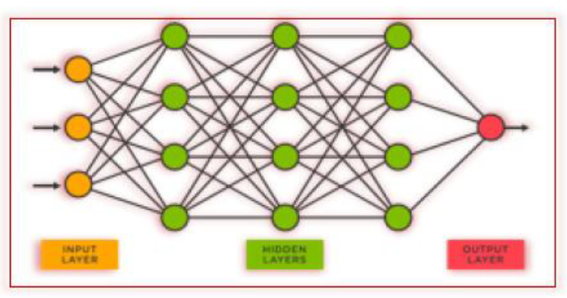 | 2
Q. 12 | Define F1 score with the formula.  F1 Score  - F1-Score provides a way to combine both precisions and recall into a single measure that captures both properties.  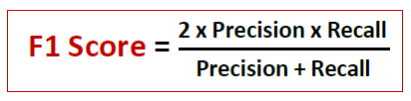 | 2
Q. 13 | Explain train-test procedure in evaluation.  Splitting the training set data for Evaluation  - The train-test split is a technique for evaluating the performance of a machine learning algorithm.  - It can be used for any supervised learning algorithm  - The procedure involves taking a dataset and dividing it into two subsets: The training dataset and the testing dataset.  - The train-test procedure is appropriate when there is a sufficiently large dataset available | 2
Q. 14 | Explain the terms in confusion matrix:  - True Positive  True Positive (TP) is the outcome of the model correctly predicting the positive class.  Eg: the cases in which we predicted yes (they have the disease), and they do have the disease.  - True Negative  True Negative (TN) is the outcome of the model correctly predicting the negative class.  Eg: the cases in which we predicted No (they don’t have the disease), and they don’t have the disease .  - False Positive  False Positive (FP) is the outcome of the model wrongly predicting the negative class as positive class.  Eg: the cases in which we predicted Yes (they have the disease), and they don’t have the disease.  - False Negative.  False Negative (FN) is the outcome of the model wrongly predicting the positive class as the negative class.  Eg: the cases in which we predicted No (they don’t have the disease), and they have the disease. | 2
Q. 15 | List the ethical concerns around model evaluation  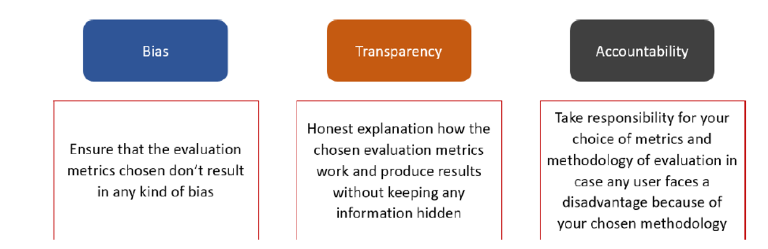 | 2
Q. 16 | What do you mean by Unsupervised Learning Model and name the Sub-categories of Unsupervised Learning Model.  An unsupervised learning model works on unlabelled dataset. This means that the data which is fed to the machine is random and there is a possibility that the person who is training the model does not have any information regarding it. The unsupervised learning models are used to identify relationships, patterns and trends out of the data which is fed into it. It helps the user in understanding what the data is about and what are the major features identified by the machine in it.  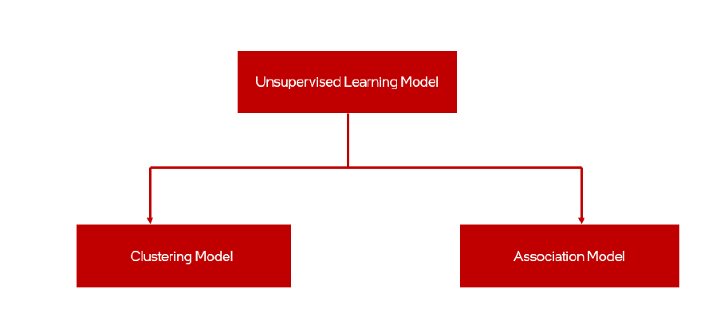 | 2

Answer any 3 out of the given 4 questions in 50– 80 words each (3x 4 = 12 marks)
Q. 17 | Explain Machine Learning with 2 real time examples.  - Machine Learning, or ML, enables machines to improve at tasks with experience. The machine learns from its mistakes and takes them into consideration in the next execution. It improvises itself using its own experiences.  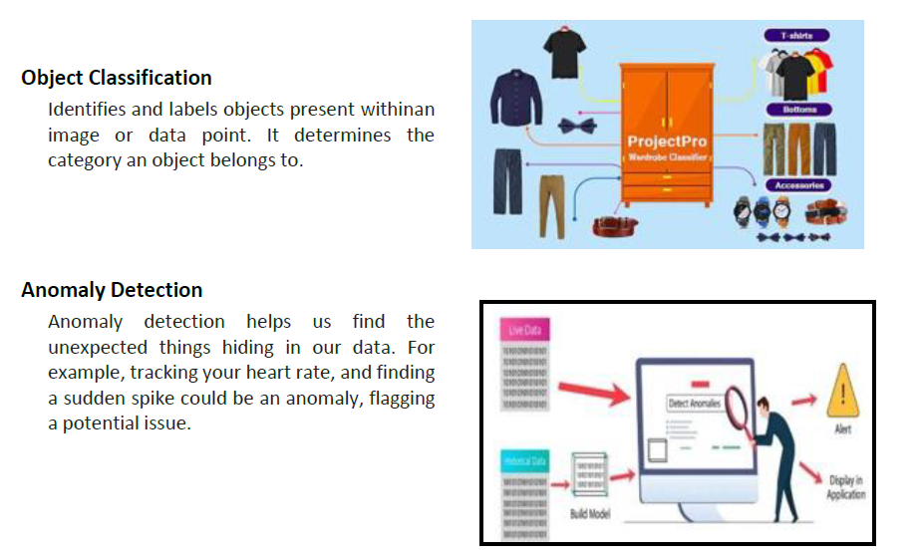 | 4
Q. 18 | Identify TP, TN, FP, FN and calculate Accuracy, Precision, Recall and F1 score for the below confusion matrix:  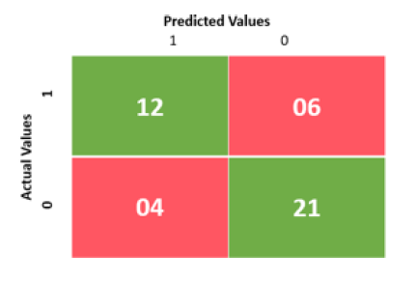  Precision: TP  TP+FP  =12/12+4  = 0.75  Recall: TP  TP+FN  =12/12+6  =0.66  F1 score: 2*Precision*Recall  Precision+Recall  =2*0.75*0.66  0.75+0.66  =0.99  1.41  =0.70 | 4
Q. 19 | Explain AI Domains with a real time example.  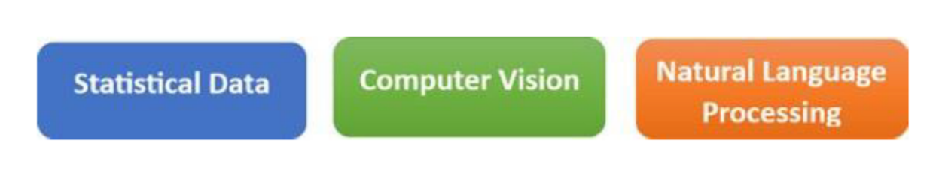  Statistical Data is a domain of AI related to data systems and processes, in which the system collects numerous data, maintains data sets and derives meaning/sense out of them.  Computer Vision, abbreviated as CV, is a domain of AI that depicts the capability of a machine to get and analyze visual information and afterwards predict some decisions about it. The entire process involves image acquiring, screening, analysing, identifying and extracting information. This extensive processing helps computers to understand any visual content and act on it accordingly.  Natural Language Processing, abbreviated as NLP, is a branch of artificial intelligence that deals with the interaction between computers and humans using the natural language. Natural language refers to language that is spoken and written by people, and natural language processing (NLP) attempts to extract information from the spoken and written word using algorithms.  Example of Statistical Data -Price Comparison Websites  Examples of Computer Vision - Agricultural Monitoring, Surveillance Systems  Examples of Natural Language Processing - Email filters , Machine Translation | 4
Q. 20 | Identify and explain the learning models shown in the picture  a. Supervised Learning  In a supervised learning model, the dataset which is fed to the machine is labelled. In other words, we can say that the dataset is known to the person who is training the machine only then he/she is able to label the data. A label is some information which can be used as a tag for data.  b. Unsupervised Learning  An unsupervised learning model works on unlabelled dataset. This means that the data which is fed to the machine is random and there is a possibility that the person who is training the model does not have any information regarding it. The unsupervised learning models are used to identify relationships, patterns and trends out of the data which is fed into it. It helps the user in understanding what the data is about and what are the major features identified by the machine in it.  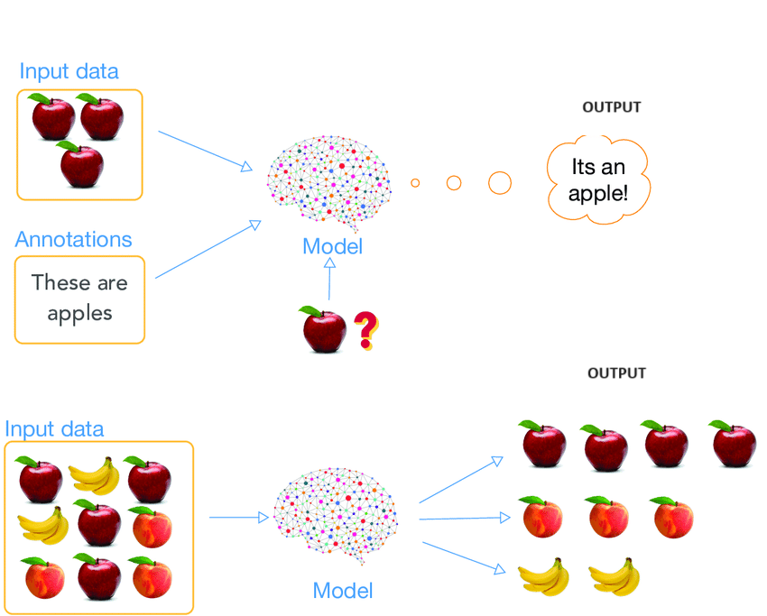 | 4

